- Introduction
Human-robot interaction (HRI) has become a hot research topic with the rapid development of robotics, sensers and artificial intelligent technologies. It is widely applied in various domains such as manufacturing, aerospace, ocean, medical applications, and so on [1].
Interaction between a human and a robot may take several forms, but these forms are influenced by whether the human and the robot are in close proximity of each other or not. Thus, communication and, therefore, interaction can be separated into two broad categories:
• Remote interaction — The human and the robot are not co-located and are separated spatially or even temporally (for example, the Mars Rovers are separated from earth both in space and time).
• Proximate interaction — The humans and the robots are co-located (for example, service robots may be in the same room as humans) [2]

Teleoperated Ultra-sound Imaging (TUSI) is a robotic application containing both remote and proximate interactions. Ultrasound imaging is inexpensive, non-ionizing, and available in a small footprint. For these reasons, ultrasound imaging is frequently used in clinical diagnosis and intervention[3]. Remote control of the ultrasound probe using robotic holds the potential to solve the shortage problem of trained experts especially in remote regions, access to ultrasound imaging can be very limited [4].
On the one hand, to achieve remote HRI (e.g. Teleoperated USI), it is important to interpret what the human intends to do and then to control the robot as human expects. For this reason, there is an increasing demand for a direct and more natural means of interface between the user and the controlled robot. A possible approach is the use of electromyographic (EMG) signals from skeletal muscles, because of their advantage of being both convenient and natural for the master [5]. Decoding human movement intention based on his/her neural signals is special in providing natural and intelligent HRI just as human controls his/her limbs [1]. EMG is the recording of electric signals generated during muscle contraction. EMG contains a large amount of information and reflects the movement intentions of a subject [6]. Additionally, Because the onset of SEMG precedes actual human movements by approximately 30–130 ms , a machine equipped with SEMG can compensate for the inherent time delay of a human–machine cooperation system [10]. As a result, we use EMG feedback from the operator upper arm and then interpret its force intended for applying by the US probe attached to the remote robot manipulator.

Safety, on the other hand, is very important in proximate HRI systems, Medical robotic ultrasound sets special safety requirements beyond the established industry standards of human-robot collaboration where direct contact between the robot and humans is typically to be avoided. Patients, who are purposely touched by the moving robot tool, are in an unprotected position with no quick escape possibility from the dangerous area and are possibly physically weakened [4]. In our case(US Imaging) , patient is directly in touch with the robot, therefore, a safety method or technique must be found on the robotic system [7]. One solution to make the robot safe is to equip the robot with a control setup that detects intentional human input and then, becomes subordinate. Compliant control (in the form of impedance or admittance) was initially proposed to provide safe and passive interactions with the environment [8]. Impedance controllers provide a compliant behavior in all phases of a contact task (e.g., non-contact, transition and contact) [9]. Moreover, using set-point adaptation strategy, it is possible to achieve both force-tracking and a reaction strategy when human intentionally interacts with the robot. (Place the diagram of safety here)

What are we doing?
In this work, we present an agile and easy-to-use framework to estimate force from EMG signal using the least required hardware and software and introducing a method for human guidance detection while robot is applying force in contact with phantom (patient body). The goal is to develop a practical setup with as much accuracy possible and reducing the amount of time and the expertise required for the whole session of teleoperated US imaging in terms of robotical setup (not the expert needed for US imaging).
The presented setup has two main parts:
1) Teleoperated Ultrasound imaging: An expert in US imaging, controls the pose and the force of the robot manipulator required for the optimum examination of the patient’s body form a remote area. Normally, the expert adjusts the probe pose and force on the body by getting the visual feedback from the US station monitor then decides on how the probe should be placed and how much pressure is required.
On the master site, the operator (US imaging expert) moves a joystick equipped with an Inertia Measurement Unit (IMU) and a computer mouse to command the orientation and the position of the probe on the remote site. Additionally, by wearing a MyoArmband on his/her upper arm to mimic the force applying on the joystick and subsequently command this estimated force from the EMG sensors to the robot arm holding the US probe at the remote site.
2) Compliancy under human interaction on remote site:
On the remote site where the robot and USI station is located, the examination is ongoing on the patient and there is typically a nurse or someone responsible to set up the examination procedure. All of whom must be able to interrupt the robot, when necessary, for example the times when patient feels uncomfortable. To satisfy this urgent need, robot must be able to detect their intention and then become fully compliant to their guidance. Developed human-detection algorithm allows remote site personnel or the patient itself to take the control of robot by simply grabbing the robot, and then moving its end-effector to any desired location without any significant resistance from the robot. Therefore, a detection and a reaction strategy must be embedded in the control loop of the system.
In the remaining of the paper, we initially delve into the examination of previous studies that employ EMG signals to estimate muscle force, with a focus on its application in robot control. Following that, we will proceed to review the various methodologies employed in human contact detection and robot compliancy. Consequently, present the practical setup parts and equipment in the study in detail. Afterwards, we go through the details of the analysis and methods for each part separately, then we make arguments about the results. In the end, we conclude and discuss further aspects of the study and future works.
- Related works
In this section, we focus on the methods for, firstly, estimation of force from EMG signals and secondly, human robot guidance detection.

2.1 EMG-based robot force control (emg-force estimation)
The utilization of surface electromyography (sEMG) for muscle force estimation has made significant progress. Muscle-force models can be categorized into two general groups namely parametric and non-parametric methods. In the first category, studies are mainly based on Hill’s muscle model [10]. Romero et al. [11] compared different Hill-type models developed by the time of publication and concluded that the selection of the most suitable model relies on factors such as computational effort, control over the parameters involved in the experiments, and the specific conditions of the problem at hand. Therefore, non-parametric methods such as polynomial fitting model [12], fast orthogonal search [13] , and parallel cascade identification [14] were introduced. Additionally, machine learning (ML) and deep learning (DL) approaches have been utilized in many robotics-related applications due to the advances in terms of algorithms, data availability and computer hardware.
One approach of ML models is called Artificial Neural Networks (ANN), which has been used to estimate muscle torque from EMG signals with no prior knowledge about the biomechanical model of engaged muscles and results in promising results [15] [16] [17]. In terms of deep learning approaches, Xu et al. [18] harnessed Long short-term memory (LSTM) and Convolutional Neural Network (CNN) to study feasibility of DL methods in estimating force from EMG. Their objective was to overcome the limited generalization observed in various ANN methods, which often resulted in poor performance in subject-independent trials. As a result of their study, LSTM proved to be a more effective way rather than conventional ANN and CNN. One possible explanation for this superiority is LSTM's ability to capture and retain long-term dependencies and patterns over extended sequences (ref).
Hajian et al. [19] proposed multiple CNN networks for generalized EMG to force mapping which takes features extracted from both time and frequency domain of EMG signal as an input. In their study, High-density electrodes were attached to three muscles, long head of biceps brachii, the short head of biceps brachii, and the brachioradialis. Although they focused on inter-subject force estimation, the networks were trained using mixed dataset containing data from all subjects at once. Therefore, testing the model on holdout data (unseen data during training) as an indication of performance from the same subjects is not alone suffice for inter-subject evaluation.
In another work by Su et al. [20] author compares deep CNN, conventional LSTM and ANN EMG-force models while the input to the network is the EMG signals by wearing MyoArmband on the forearm of subject and reported a better performance for deep CNN. However, from biomechanical view-point, the force induced on human wrist is mainly resulted from upper arm muscles [21] and not those in forearm. Therefore, the underperformance of the other models, apart from deep CNN, could be attributed to inherent biomechanical factors.
Nasr et al. [22] proposed a comprehensive methodology for EMG-force/kinematic modelling called MuscleNet. Although their method showed high accuracy, their data gathering and preprocessing is rather complicated in terms of both EMG electrode types (requires shaving and swabbing) and also their total number (eleven). Consequently, making their models difficult or impossible to implement on a practical setup.
In above studies, models were tested against offline data gathered before training and no real-time experiment was conducted. Zhang et al. [1] collected EMG data from seven different muscles of human arm aiming toward simultaneous force and joint angle estimation during the supination and pronation movement. Their model was a LSTM network and input to the network was the feature extracted using Bayesian filter. To evaluate their model, they also trained an ANN for the purpose of comparison and as a result, LSTM performed significantly better in real-time experiment though they both exhibit a decay in final performance. According to the authors in [1], one potential explanation is that ANNs solely rely on the inputs from the current time step to estimate the output, making them vulnerable to short-term noises.
In this work, we propose a framework for emg-force modelling that can be used in a practical non-academic environment. In various applications like surgical and rehabilitation robotics, it is crucial for a model to possess the capability to estimate force across different users without having access to prior data from individual users. To do so, reducing the time required for the setup, which consists of four main parts, EMG electrode placement, data acquisition session and training the model and at last, implementation of the model on the real-time setup. Consequently, it is not mandatory to develop a generalized method specially when there is a large gap between the real-time performance of the models (we will further discuss in results section) due to some possible reasons such as electrode shift, fatigue, individual biological difference, and their performance assessed based on test data that was gathered in the same session as the training set.
To achieve such an agile and high-performance setup, we use MyoArmban for EMG signal acquisition, worn on the upper arm of the subject. Moreover, an LSTM architecture is used for EMG-force modelling which has proved to be more efficient in temporal data [1], [18]. Next, by implementing the model and data preprocessing routine on a computer software in the same session, we assess the real-time performance of the model without having the subject to take the MyoArmband off. This is a more efficient way since electrode shift could be a huge barrier to generalized methods to reproduce the same results [23] for not only inter-subject EMG-force modelling but also, for the same subject in different sessions.
2.2 Human interaction detection and compliancy
Human intentional guidance or intentional collision detection can be divided into two main categories data-driven and model-based approaches [7]. Data-driven approaches in robot collision detection involve utilizing large datasets to train models for accurately detecting and preventing collisions. These approaches emphasize the importance of task demonstration, where the robot learns from examples of the task being performed to effectively detect and respond to potential collisions [24] [25] [26]. However, in the case of US imaging, the robot trajectory varies vastly in each diagnosis session. In other words, force and pose of the US probe must be adjusted by the operator in real-time and no two sessions or trials are the same, which means that the recording of the robot sensory data, or even its path is unknown and different. Therefore, it is not applicable to use data-driven methods for this application.
On the other hand, in model-based methods, impedance/admittance control is widely used to both detect the collision or human guidance and the strategy of reaction. Walid et al. [27] considers the human interaction as a large disturbance on the robot executing a task e.g. Polishing. They use Dynamical System as a representative of the task which is a time-independent trajectory planner and when a disturbance occurs controller re-plans the execution of the contact task from the disturbed state. However, by using markers and a planned trajectory for both force and position, their method is dependent on the known surface while preserving compliancy. There are studies that address the unknown environment issue [28] and not having or requiring the pre-planned trajectory [29] but they do not investigate the human-guidance detection.
In some studies, an approach was proposed so that the robot switched between the different states [30] , [8], [31] ; Khoramshahi et al. [8] harnesses an admittance controller to sense the external forces exerted on robot while performing a task based on trajectory generated from a dynamical system. This trajectory contains the pose and orientation of the robot manipulator. However, their method can be only applied to the cases where robot is merely in position control. As a result, their algorithm is not capable to differentiate between the contact task and human interaction force, make their algorithm not applicable for the US imaging task where there is intentional contact between the robot and environment e.g. phantom or the patient in the US session. Inspired by the above methodology, we propose a detection algorithm that switches between two states, a leader role - EMG-driven force controlled- and a follower role. One that the robot is leader, the force/pose command must be controlled and in second role, follower, robot becomes compliant to the external forces induced by human. Moreover, In the follower scheme, the robot not only neglects the force command from the operator (EMG-muscle force) but also, requires minimum effort from the human to move its body as he/she desires due to the impedance set-point (e.g., reference position) adaptation controller [32] [33]. We propose a method to achieve compliancy by setting the desired force at the end-effector to zero and also, having a floating-set-point.
In summary, we introduce a detection algorithm based on energy tanks considering the differentiation between task contact force and human interaction force. After detection of human interaction, to achieve compliancy, we take advantage of the presented force controller methodology so that the robot becomes fully passive to human guidance.
(the relationship is called impedance when force is generated from motion deviation and admittance in the opposite way)
- Experimental setup and parts
Model trainings were conducted on a Windows machine (Core i7 7th generation, 16 GB RAM)
And then transferred to the Laboratory PC
- Methods
  - Force estimation from EMG
    - Data Acquisition
Three healthy subjects (two males, one female) aged between 25 to 27 participated in this study. All of whom signed informed consent form. Sampling is performed in such a way that subject wears the MyoArmband on their upper-arm and applies force on tip of the KUKA robot (Figure 1). At the same time, the data related to surface EMG electrodes and the force applied to the robot's tool tip are recorded. The recorded dataset is sampled from the elbow joint at various angles and in a static manner. Considering that there is no movement when applying force to the robot, isometric flexion and extension occurs. The robot communicates with the central computer through a network connection. Additionally, the Armband communicates wirelessly and via Bluetooth protocol with the central computer. A C++ software is responsible to record both robot data and EMG data in a synchronous matter. The sampling frequency is 178 Hz.
In terms of the force pattern, subjects were asked to perform different levels of their maximum voluntary contraction in either pronation or supination due to the random nature of the applied force in a US imaging session. In other words, there is no specific force trajectory for subjects to follow.
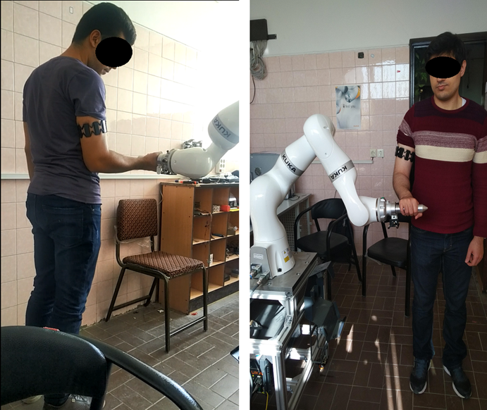
Figure 1 Data acquisition setup. Subjects perform pronation and supination in different elbow angles (left: 90 degree, Right: 110 degree). Robot’s configuration is adjusted such that the elbow angle of each subject will be related to their height.
    - Data preprocessing
In this paper, EMG signals were rectified and then three out of 8 EMG channels with the strongest correlation to force values were identified through correlation analysis, contributing to the selection of informative features. Where two of these channels correlate with negative force and one of the channels with positive force. Next, a third-order low-pass filter with a frequency of 178 Hz and a cut-off frequency of 3 Hz is applied to the data and the force data and normalized to their maximum value in each data.
    - Force estimation model
The modeling of force in this study is done by Feed Forward Neural Network (FFNN) and Long Short-term Memory (LSTM) where the first one is used as a benchmark. Since ANNs are widely used for EMG to force/torque and kinematic variables mapping [1]. The ANN used for force estimation consists of two layers, with three inputs- selected EMG channels- and one output. The first layer comprises ten neurons with a tangent sigmoid activation function, while the second layer consists of one neuron with a linear activation function. Choosing the number of neurons in the first layer was based on different trial and error steps to determine the best network performance with various number of neurons. Network then trained using Levenberg-Marquardt algorithm with mean-squared error as loss.
Long Short-Term Memory, is a type of recurrent neural network architecture designed to handle sequential and time-series data. It addresses the vanishing gradient problem by utilizing a specialized memory cell and a set of gating mechanisms, including input, forget, and output gates. These mechanisms enable LSTMs to capture and remember long-range dependencies in data while selectively updating and preserving relevant information over time, making them effective for tasks involving sequential patterns and context [34]. Hence, utilize LSTM for acquiring the relationship between sEMG and force, adopting a distinct approach within this study. Our model comprises a four-layer architecture encompassing a sequence input layer, an LSTM layer, a fully connected layer, and a regression output layer (figure…). The input to the LSTM is also the 3 selected channels of EMG signals and output is force value at each time step. The LSTM layer is equipped with 8 hidden units. We employ root mean square error (RMSE) as the loss function to optimize the network's performance. Training occurs with mini-batches of size 20, over the course of 600 epochs, utilizing the Adam optimizer. The application of a gradient threshold at 1.0 curbs the risk of gradient explosion. Our learning rate initiates at 0.02.
    - Performance indices
To comprehensively evaluate the efficacy of the models during both the training phase and real-time estimation, we employ three distinct performance indices: Regression (R), root mean square error (RMSE), and the coefficient of determination R-squared. Among these, R-squared emerges as the most informative and widely recognized performance index for regression analyses [35].
The root mean square error (RMSE) is formulated as follows:
$$RMSE=\sqrt{\frac{∑{(f_{i}-{\hat{f}}_{i})}^{2}}{n}}$$
Here, $f_{i}$ represents the actual force value, ${\hat{f}}_{i}$ denotes the estimated force value, and $n$ signifies the total number of data points.
The coefficient of determination R-squared is calculated through the Residual Sum of Squares (RSS), providing valuable insights into the model's ability to account for the variance in the observed force values. Its formulation is:
$$R^{2}=1-\frac{RSS}{TSS}$$
Where RSS stands for the Residual Sum of Squares and TSS refers to the Total Sum of Squares.
In employing these performance indices, we gain a comprehensive understanding of the models' accuracy, predictive power, and overall fit to the force estimation task.
Compliancy
- force Control
Unlike previous studies [8], [27] where the desired path of the robot is known, in the present study, the robot must apply a specific force to the surface without knowing its geometric shape and distance from the robot's tool-US probe. This force is obtained from the electromyography signal.
Admittance controller
The control of the target force was carried out using the built-in impedance mode of the Kuka LBR iiwa robot. The main idea of controlling the force through impedance is that the robot's tool is virtually connected to a spring-damper system. Therefore, to apply a specific force, it is sufficient to adjust the position of the robot relative to the contact surface of the tool and the object. This creates a deviation in the virtual spring, which generates a force according to the Hooke's law (pic bellow).
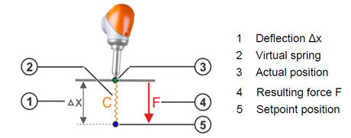
Figure 2 Deflection $∆x$ and virtual spring stiffness determines the force applied on surface
On the other hand, the nature of ultrasound imaging is such that knowing the position or geometry of the surface is not possible, mostly due to the diversity of examinations (different parts of the body, differences in the physical shape of patients). Therefore, the algorithm used to apply force is designed in such a way that the robot is always adjusting to a new target position in the direction where force is supposed to be applied, which causes the tool to move towards the desired surface. After the tool contacts the surface, the robot stops moving and only applies force. It can be concluded that if the target force is zero, ΔX will be zero and the robot will not move.
Here the complete diagram
- Motion compliancy definition
It can be concluded that if the target force is zero, ΔX will be zero and the robot's target position will be equal to its current coordinates. If a human moves the robot's tool with applying a small force, due to the spring-damper nature of the robot's behavior, the robot will deviate slightly from its previous position. In other words, the robot will have the properties of compliant follower.
However, in situations where the target force $F_{desired}$ is not zero, in addition to applying the external force needed to deviate the robot from its current position, the human also needs to overcome the target force, making it difficult and even impossible to move the robot. In other words, the robot will insist on applying force or moving in the opposite direction.

Therefore, the following formula is used to achieve force control and simultaneous compliancy of the robot:

$$f_{d}=(1-h)f_{t}$$

الگوریتم مورد استفاده برای روبات سازگار در حین انجام وظیفه‌ای که نیاز به اعمال نیرو دارد.

In this equation, h ∈ [0,1] is a scaling factor that will be obtained by the human interaction recognition algorithm. $f_{t}$ is the desired task force, which is estimated from the EMG sensor. Finally, $f_{d }$will be sent to the force controller. The concept of the above equation is that by detecting human interaction, the robot abandons its task and becomes compliant. In other words, it changes from the Active state to the Passive state.

- Human detection algorithm
This method differs from collision detection in that it does not require information about the joint torques. Additionally, this algorithm does not require precise knowledge of the robot's dynamics, and the energy calculations of the robot (resulting from human intervention) extracted using a different method.

Since the robot is in impedance control mode, it is not stiff in any stage while working, and it acts like a spring-damper system. Therefore, when the human intervenes, the robot's state variables change proportionally to the force applied by the human.

Initially, to determine whether the changes in the robot's motion and force components are due to continuous intention and not just momentary collision, a virtual impedance is simulated as follows:

(۳- 50) | $$M_{a}\ddot{x}=-D_{a}\dot{x}+\tilde{f_{i}}$$
where x∈R is the robot's instantaneous position. Using this virtual impedance, the force $\tilde{f_{i}}$, which causes the robot's motion, can be calculated. Using $\tilde{f_{i}}$, we calculate the following power parameters:

$${\tilde{P}}_{i }=\dot{x} \tilde{f_{i}}$$
$${\tilde{P}}_{o}={\dot{\tilde{x}}}_{h} \tilde{f_{i}}$$

${\tilde{P}}_{i }$and ${\tilde{P}}_{o}$ are input and output power respectively. Next step is to define an energy tank E, with the following dynamic:

$$\dot{E}= {\tilde{P}}_{i }- {\tilde{P}}_{o}-\left(1-h\right)P_{d}$$
where $P_{d}>0$ is a dissipation rate that is modulated by human-interaction ratio ,h. This energy is limited between 0 and $E_{m}$. Human-guidance ratio h is decided based on stored energy in the tank as follows.

$$h=\left\{\begin{aligned}0 &E≤E_{t} \\ \frac{E-E_{t}}{E_{m}-E_{t}} &E>E_{t}\end{aligned}\right.$$
$E_{t}$ is the minimum amount that the energy tank must be filled with for the detection algorithm to work. The following value is updated at each time step:

$${\dot{\tilde{x}}}_{h}=h\dot{x}$$
The coefficient h, if equal to 1, means complete motion compliancy, and the robot will become completely obident.

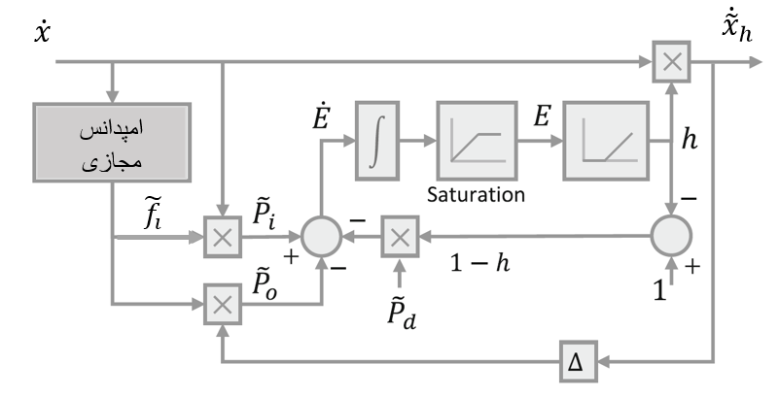
Figure 3 Block diagram of the human-detection algorithm
- Results
In this section, we first examine the efficacy of the methods to estimate muscle force in different subjects in both offline training phase and in online estimation on practical setup. Then, we go through the results of compliancy scheme and human guidance detection algorithm.
  - Estimation results of EMG to Force mapping
Here, we first present the performance of the networks trained with data for two subjects when performing the flexion/extension in different elbow angles. Then, we investigate real-time accuracy of methods for subject one left and right arm.
Note that, for each subject or trial, selected channels might differ due to the difference in MYOarmband location on upper arm. The reason behind this is that at each session or different subjects, it is impossible to place the electrode at the exact same location as the other subjects or sessions.
In table (1) and (2) both LSTM and ANN networks are trained using only data of 90-degree dataset to examine the effect of elbow angle deviationon the performance of trained networks. Since the performance varies
Table 1 offline trainig results for subject one. (*) indicates the dataset used as the trainig set. Here, 70 percent of 90 degree data were used as training, 15% as test and 15% for validation. Then, the trained networks tested against other data sets which means all of other data were used for testing the trained model. In each elbow configuration, at least 11997 data points are recorded.
Model | Feed Forward |  |  | Long Short-term Memory
Elbow angle | RMSE | R | R-squared | RMSE | R | R-squared
60 | 0.26 | 0.86 | 0.61 | 0.23 | 0.95 | 0.78
70 | 0.25 | 0.88 | 0.65 | 0.17 | 0.96 | 0.87
90* | 0.24 | 0.85 | 0.63 | 0.09 | 0.98 | 0.95
110 | 0.27 | 0.81 | 0.58 | 0.15 | 0.94 | 0.87

Table 2 We can see a more consistent behavior in LSTM performance -decaying indices as elbow degree distances from 90 degree- while in FFNN some of the distant datasets from the 90-degree showed better results i.e. 110- and 50-degree dataset has higher performance than 70- , 80- and 100-degree.
Model | Feed Forward |  |  | Long Short-term Memory
Elbow angle | RMSE | R | R-squared | RMSE | R | R-squared
50 | 0.32 | 0.95 | 0.74 | 0.27 | 0.99 | 0.77
70 | 0.30 | 0.93 | 0.69 | 0.23 | 0.98 | 0.78
80 | 0.29 | 0.90 | 0.65 | 0.18 | 0.98 | 0.86
90* | 0.16 | 0.97 | 0.94 | 0.08 | 0.99 | 0.97
100 | 0.34 | 0.88 | 0.55 | 0.22 | 0.97 | 0.80
110 | 0.33 | 0.91 | 0.71 | 0.26 | 0.97 | 0.78

  - Compliancy result
The robot is only under force control along the Z-axis of the Cartesian coordinate system and under position control along the other two axes. After human intervention to take control of the robot, the human detection algorithm calculates the human interaction ratio (h), which changes from 0 to 1, and the robot will enter a compatible state.
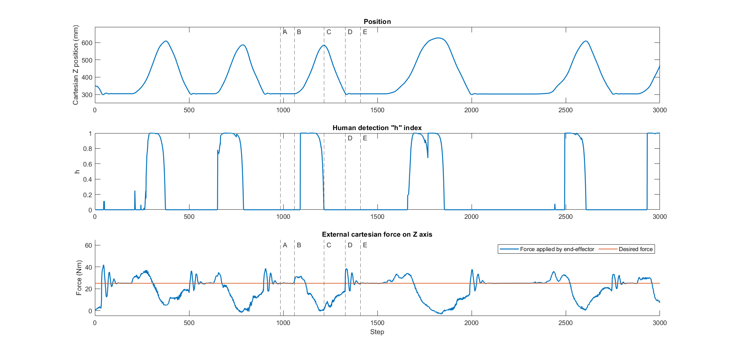
Figure 4Data regarding human-detection index
As shown in the figure above (3) , there are four stages from the moment of human intervention to the continuation of the main robot task:

Stage A to B: In this stage, based on the graph (iii), the robot applies a force of 25 Newtons (estimated from the EMG signal) to the lower surface of the end-effector. The tool's tip remains tangent to and stationary on the surface (i).

Stage B to C: At point B, the human starts moving the tool tip and takes it out of the Cartesian equilibrium point. After a few time steps, as seen in graph (ii), the interaction detection index h increases towards 1. In graph (iii), right after human intervention, and by lifting the robot's tool upward (point B), we observe an increase in the force applied to the robot (and consequently, the force exerted by the robot on the human). Subsequently, with an increase in h, the robot's force (applied to the human) not only does not increase further but starts to decrease, and this force decreases towards zero. Here, it can be acknowledged that the robot has entered a compliance state, and moving it by a human operator becomes possible without any resistance from the robot. It is worth mentioning that the sudden increase in h is due to the existence of restrictive constraints in calculating the energy in the reservoir in a way that minor energy variations do not increase the interaction index.

Stage C to D: At point C, the human releases the robot's end-effector, and due to the presence of the damping coefficient in formula (7, Khormaee), the index h reaches 0 in a short period (by increasing or decreasing this coefficient, the time for h to reach zero or, in other words, the time for the robot to be compatible after detecting the intervention can be changed). At this stage, the robot is not in contact with any external surface, and the external force on the robot is still lower than the desired force.

Stage D to E: At this point, the robot's tool makes contact with a surface, resulting in a sudden increase in the value of the external force. After observing oscillations in the external force, it becomes equal to the desired force.

For a better understanding of the impact of the presented algorithm, the data for two different sampling instances are shown in the figure, where in (A) the human interaction algorithm is active, and in (B) the robot only has impedance control and force application. By comparing the external force on the robot in the two figures from B to C and calculating the average external force applied to the robot by the human, it becomes evident that the human needs to do more work to guide the robot in graph (B).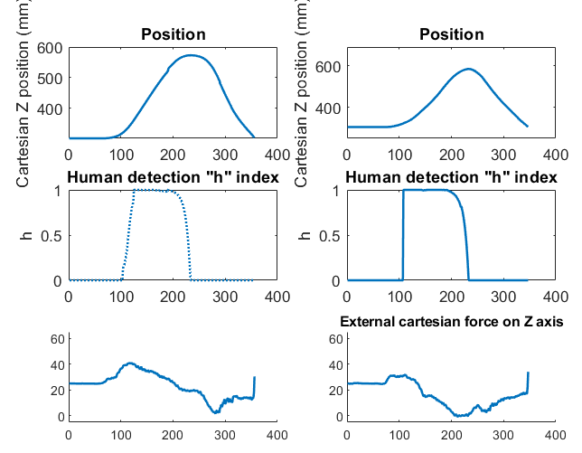
Figure The left column represents the case without applying h, and the right column represents the case with h. The examined range is when h is greater than 0, indicating human guidance. By comparing the corresponding section in the external force graph in both cases, a significant decrease in force can be observed in the left graph. In other words, from the moment h becomes equal to 1, the force in the left graph exceeds 25 Newtons (the target force from EMG), while in the right graph, the force is decreasing towards 0.
در دو راستای X و Y کارتزین ضریب تعدیل محاسبه شده توسط الگوریتم سازگاری روبات از طریق نیروی خارجی وارد بر آن محاسبه می‌شود. دلیل این موضوع عدم اعمال نیروی مشخص عمدی از سوی روبات است که در مطالعه پیشین مورد بررسی قرار گرفته است [8]. اگرچه که ربات همچنان در حالت مد کنترل امپدانسی است و بر خلاف مطالعه خرمشاهی و همکارش در صورت اعمال نیرو به خاطر ماهیت فنری، متناسب با آن از موقعیت کنونی منحرف میشود.

[1] Q. Zhang, L. Fang, Q. Zhang, and C. Xiong, “Simultaneous estimation of joint angle and interaction force towards sEMG-driven human-robot interaction during constrained tasks,” Neurocomputing, vol. 484, pp. 38–45, May 2022, doi: 10.1016/J.NEUCOM.2021.05.113.
[2] M. A. Goodrich and A. C. Schultz, “Human – Robot Interaction : A Survey,” vol. 1, no. 3, pp. 203–275, 2007, doi: 10.1561/1100000005.
[3] R. Monfaredi, E. Wilson, B. A. Koutenaei, B. Labrecque, and K. Leroy, “Robot-assisted ultrasound imaging : Overview and development of a parallel telerobotic system Robot-Assisted Ultrasound Imaging : Overview and Development of a Parallel Telerobotic System,” no. February 2015, 2014, doi: 10.3109/13645706.2014.992908.
[4] F. von Haxthausen, S. Böttger, D. Wulff, J. Hagenah, V. García-Vázquez, and S. Ipsen, “Medical Robotics for Ultrasound Imaging: Current Systems and Future Trends,” Curr. Robot. Rep. 2021 21, vol. 2, no. 1, pp. 55–71, Feb. 2021, doi: 10.1007/S43154-020-00037-Y.
[5] K. J. Kyriakopoulos, “EMG-based Position and Force Control of a Robot Arm : Application to Teleoperation and Orthosis,” pp. 1–6, 2007.
[6] D. Xiong, D. Zhang, X. Zhao, and Y. Zhao, “Deep Learning for EMG-based Human-Machine Interaction : A Review,” IEEECAA J. Autom. Sin., vol. 8, no. 3, pp. 512–533, 2021.
[7] A. N. Sharkawy and P. N. Koustoumpardis, “Human–Robot Interaction: A Review and Analysis on Variable Admittance Control, Safety, and Perspectives,” Machines, vol. 10, no. 7, pp. 1–24, 2022, doi: 10.3390/machines10070591.
[8] M. Khoramshahi and A. Billard, “A dynamical system approach for detection and reaction to human guidance in physical human-robot interaction,” Auton. Robots, vol. 44, no. 8, pp. 1411–1429, 2020, doi: 10.1007/s10514-020-09934-9.
[9] W. Amanhoud, M. Khoramshahi, M. Bonnesoeur, and A. Billard, “Force Adaptation in Contact Tasks with Dynamical Systems,” Proc. - IEEE Int. Conf. Robot. Autom., pp. 6841–6847, 2020, doi: 10.1109/ICRA40945.2020.9197509.
[10] A. V. Hill, “The heat of shortening and the dynamic constants of muscle,” Proc. R. Soc. Lond. Ser. B - Biol. Sci., vol. 126, no. 843, pp. 136–195, Jan. 1997, doi: 10.1098/rspb.1938.0050.
[11] F. Romero and F. J. Alonso, “A comparison among different Hill-type contraction dynamics formulations for muscle force estimation,” Mech. Sci., vol. 7, no. 1, pp. 19–29, Jan. 2016, doi: 10.5194/ms-7-19-2016.
[12] E. A. Clancy and N. Hogan, “Relating agonist-antagonist electromyograms to joint torque during isometric, quasi-isotonic, nonfatiguing contractions,” IEEE Trans. Biomed. Eng., vol. 44, no. 10, pp. 1024–1028, Oct. 1997, doi: 10.1109/10.634654.
[13] “No Title”, [Online]. Available: https://ec.europa.eu/info/research-and-innovation/research-area/industrial-research-and-innovation/industry-50_en
[14] J. Hashemi, E. Morin, P. Mousavi, K. Mountjoy, and K. Hashtrudi-Zaad, “EMG-force modeling using parallel cascade identification,” J. Electromyogr. Kinesiol. Off. J. Int. Soc. Electrophysiol. Kinesiol., vol. 22, no. 3, pp. 469–477, Jun. 2012, doi: 10.1016/j.jelekin.2011.10.012.
[15] F. Mobasser and K. Hashtrudi-Zaad, “A Comparative Approach to Hand Force Estimation using Artificial Neural Networks,” Biomed. Eng. Comput. Biol., vol. 4, p. BECB.S9335, Jan. 2012, doi: 10.4137/BECB.S9335.
[16] M. H. Jali, M. F. Sulaima, and T. A. Izzuddin, “Comparative Study of EMG based Joint Torque Estimation ANN Models for Arm Rehabilitation Device,” vol. 9, no. 10, pp. 1289–1301, 2014.
[17] J. Luo, C. Liu, and C. Yang, “Estimation of EMG-Based force using a neural-network-based approach,” IEEE Access, vol. 7, pp. 64856–64865, 2019, doi: 10.1109/ACCESS.2019.2917300.
[18] L. Xu, X. Chen, S. Cao, X. Zhang, and X. Chen, “Feasibility study of advanced neural networks applied to sEMG-based force estimation,” Sens. Switz., vol. 18, no. 10, Oct. 2018, doi: 10.3390/S18103226.
[19] G. Hajian, A. Etemad, and E. Morin, “Generalized EMG-based isometric contact force estimation using a deep learning approach,” Biomed. Signal Process. Control, vol. 70, no. July, p. 103012, 2021, doi: 10.1016/j.bspc.2021.103012.
[20] H. Su, W. Qi, Z. Li, Z. Chen, G. Ferrigno, and E. De Momi, “Deep Neural Network Approach in EMG-Based Force Estimation for Human-Robot Interaction,” IEEE Trans. Artif. Intell., vol. 2, no. 5, pp. 404–412, 2021, doi: 10.1109/TAI.2021.3066565.
[21] S. Buchanan, W. Z. E. V. Rymer, P. J. Almdale, L. Lewis, S. Motor, and P. Program, “Characteristics of Synergic Relations During Isometric Contractions of Human Elbow Muscles,” no. 5, 1986.
[22] A. Nasr et al., “MuscleNET: Mapping electromyography to kinematic and dynamic biomechanical variables by machine learning,” J. Neural Eng., vol. 18, no. 4, p. 0460d3, Aug. 2021, doi: 10.1088/1741-2552/ac1adc.
[23] E. A. Clancy, C. Martinez-Luna, M. Wartenberg, C. Dai, and T. R. Farrell, “Two degrees of freedom quasi-static EMG-force at the wrist using a minimum number of electrodes,” J. Electromyogr. Kinesiol. Off. J. Int. Soc. Electrophysiol. Kinesiol., vol. 34, pp. 24–36, Jun. 2017, doi: 10.1016/j.jelekin.2017.03.004.
[24] F. Franzel, T. Eiband, and D. Lee, “Detection of Collaboration and Collision Events during Contact Task Execution,” IEEE-RAS Int. Conf. Humanoid Robots, vol. 2021-July, pp. 376–383, 2021, doi: 10.1109/HUMANOIDS47582.2021.9555677.
[25] K. M. Park, Y. Park, S. Yoon, and F. Park, “Collision Detection for Robot Manipulators Using Unsupervised Anomaly Detection Algorithms,” IEEEASME Trans. Mechatron., vol. 27, no. 5, pp. 2841–2851, Oct. 2022, doi: 10.1109/TMECH.2021.3119057.
[26] M. Lippi, G. Gillini, A. Marino, and F. Arrichiello, “A Data-Driven Approach for Contact Detection, Classification and Reaction in Physical Human-Robot Collaboration,” Proc. - IEEE Int. Conf. Robot. Autom., vol. 2021-May, pp. 12730–12736, 2021, doi: 10.1109/ICRA48506.2021.9561827.
[27] W. Amanhoud, M. Khoramshahi, and A. Billard, “A Dynamical System Approach to Motion and Force Generation in Contact Tasks,” 2019, doi: 10.15607/rss.2019.xv.021.
[28] J. Li, Y. Guan, H. Chen, B. Wang, and T. Zhang, “Robotic Polishing of Unknown-Model Workpieces With Constant Normal Contact Force Control,” IEEEASME Trans. Mechatron., vol. PP, pp. 1–11, Jan. 2023, doi: 10.1109/TMECH.2022.3216314.
[29] M. S. Erden and A. Billard, “Robotic Assistance by Impedance Compensation for Hand Movements while Manual Welding,” IEEE Trans. Cybern., vol. 46, no. 11, pp. 2459–2472, 2016, doi: 10.1109/TCYB.2015.2478656.
[30] P. Evrard and A. Kheddar, “Homotopy switching model for dyad haptic interaction in physical collaborative tasks,” Proc. - 3rd Jt. EuroHaptics Conf. Symp. Haptic Interfaces Virtual Environ. Teleoperator Syst. World Haptics 2009, pp. 45–50, 2009, doi: 10.1109/WHC.2009.4810879.
[31] A. Bussy, P. Gergondet, A. Kheddar, F. Keith, and A. Crosnier, “Proactive Behavior of a Humanoid Robot in a Haptic Transportation Task with a Human Partner,” presented at the Proceedings - IEEE International Workshop on Robot and Human Interactive Communication, Sep. 2012, pp. 962–967. doi: 10.1109/ROMAN.2012.6343874.
[32] S. Jung, T. C. Hsia, and R. G. Bonitz, “Force tracking impedance control of robot manipulators under unknown environment,” IEEE Trans. Control Syst. Technol., vol. 12, no. 3, pp. 474–483, May 2004, doi: 10.1109/TCST.2004.824320.
[33] L. Roveda, N. Iannacci, F. Vicentini, N. Pedrocchi, F. Braghin, and L. M. Tosatti, “Optimal Impedance Force-Tracking Control Design With Impact Formulation for Interaction Tasks,” IEEE Robot. Autom. Lett., vol. 1, no. 1, pp. 130–136, Jan. 2016, doi: 10.1109/LRA.2015.2508061.
[34] F. A. Gers, J. Schmidhuber, and F. Cummins, “Learning to forget: Continual prediction with LSTM,” Neural Comput., vol. 12, no. 10, pp. 2451–2471, 2000, doi: 10.1162/089976600300015015.
[35] D. Chicco, M. J. Warrens, and G. Jurman, “The coefficient of determination R-squared is more informative than SMAPE, MAE, MAPE, MSE and RMSE in regression analysis evaluation,” PeerJ Comput. Sci., vol. 7, pp. 1–24, 2021, doi: 10.7717/PEERJ-CS.623.

